NOVENA PRAYER TO BLESSED ARTEMIDE ZATTI

In the name of the Father and of the Son and of the Holy Spirit. Amen

Glory to the Holy Trinity

God our Father, you constantly raise co-workers among your people, sharing with them your design for the Salvation of the whole world. You called the Blessed Artemide Zatti to make visible among your beloved children the beauty of an ardent love for you and the strength of a tender compassion for the poorest.

Glory be to the Father and to the Son and to the Holy Spirit…

Lord Jesus, you make those you call to follow you more closely to identify themselves with you, to be totally Christ-like. In the blessed Salesian Brother Artemide Zatti you gave us a shining example of a radical approach to the Gospel.

Glory be to the Father and to the Son and to the Holy Spirit…

Divine Spirit, giver of life: those the Father calls, through you partake in the life and mission of the Church, becoming living and life-giving members of Christ’s body. You sent Blessed Artemide Zatti as the Good Samaritan with don Bosco’s smile.

Glory be to the Father and to the Son and to the Holy Spirit…

Prayer of intercession for vocations to Salesian Brotherhood

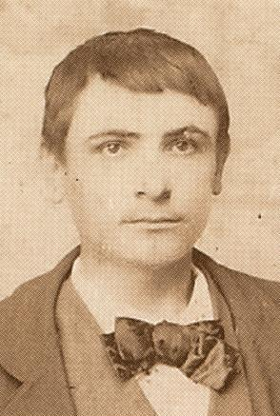
Father of mercy,
in Blessed Artemide Zatti
you gave us a wonderful model of Salesian Brother:
help us to realize the beauty of this specific vocation
for the entire Salesian Family.

Give us pastoral zeal and wisdom
so to be for our young people
good prophets of this ‘hand of don Bosco’:
the hand of the Salesian Brother,
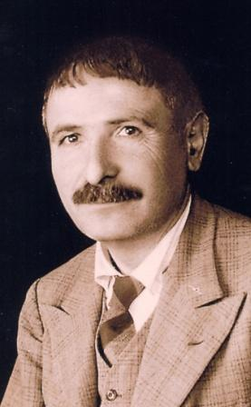
a Gospel’s way of following Christ at the service
of the poorest among the youth.

Open the heart of your children to the working of the Spirit,
Particularly those young people you led,
with the motherly intercession of Mary,
to the houses of don Bosco.
Let them be attracted and fascinated by your voice;
let them respond a generous AMEN to your appeal.


Train and lead us in your Providence,
so that we will be able to accompany
those you call to this very way of life
with a good experience of formation,
in communities that mirror the Oratory of don Bosco.

We ask this through the intercession of
Blessed Artemide Zatti, loving son
of Mary Help of Christians.

We ask this with the humble filial trust
we learn from your Son who taught us how to pray.
All we desire, all we pray for, all we hope
through Christ our Lord. Amen

Prayer of intercession for personal particular intentions

Formulate your intention with your words in a moment of silent prayer.

Entrust your intention in prayer to the intercession of Blessed Artemide Zatti and pray with the same most precious prayers he wholeheartedly cherished throughout his entire life:

Our Farther, Hail Mary, Glory be to the Father…

Final Prayer

O God of the Universe,
You choose to show the depth and the breath
of the magnificent works of your grace
in your humblest and lowliest children,

Humbly we pray that,
through the intercession of Blessed Artemide Zatti,
in our brothers and sisters who are suffering in body and in spirit,
we may see day after day, more and more clearly,
the radiant countenance of Christ,
your Son, our Brother, our Lord.

Amen.

